|  |  |
| --- | --- |
|  | |
| Application User Requirements Specifications |
|  |

|  |  |
| --- | --- |
| Document ID: | RIV_URS_01.00 |
| Document Version: | 0.1 |
| Document Status: | Under Development |
| Document Author: | Duncan Appelbe |
|  |  |
| Template: | OIT-001 |
| Template Version | 2.0 |
| Template Effective Date: | 28Mar2016 |

Reviewers and Approvers

|  |  |  |  |
| --- | --- | --- | --- |
| Role | Name and title | Date | Signature |
| Author: | | | |
|  | Duncan Appelbe |  |  |
| Review and approval: | | | |
| Ensuring the requirements meets the functional needs for the application. | OCTRU IT |  |  |
| Ensuring the requirements described can be met technically | OCTRU-IT |  |  |
| [as per the Quality/Validation Plan] | OCTRU HUB MANAGEMENT/TRIAL TEAM MANAGEMENT |  |  |

Version Control

| Version | Date | Author | Change Descriptions |
| --- | --- | --- | --- |
| V00.01 | 21-May-2019 | Duncan Appelbe | Initial Version |

Table of Contents

Reviewers and Approvers 2

Version Control 2

Table of Contents 3

1. Introduction 4

1.1 Purpose 4

1.2 Scope 4

2. Overview 4

3. Glossary 4

4. References and Associated Documents 4

5. Detailed Risk Assessment 5

6. Requirements Information 5

6.1 Requirement ID 5

6.2 Requirement Risk Severity 5

7. User Requirements for 6

8. Core Business Requirements 7

9. Common Technical Requirements for the system 7

10. Reporting Requirements 8

# Introduction

## Purpose

The User Requirement Specification captures the business needs of the system. This document also states any constraints and defines regulatory requirements if applicable. It describes the features or capabilities needed in order to meet the business goals and objectives of the project. Traceability between User Requirement Specifications, Functional Specifications, Technical Specifications and the Test scripts is maintained in the Requirement Traceability Matrix (RIV_RTM_01.00).

## Scope

This User Requirement Specification is the document defining the user requirements for the Research Image Viewer that will be used by the adjudication committee to check for eligibility based on medical scans.

The scope of this document the User Requirements for the creation and management of the application.

# Overview

An application is required to facilitate the analysis/adjudication of images used in clinical studies. This application should be web-based

# Glossary

|  |  |
| --- | --- |
| Term | Definition |

# References and Associated Documents

| Document ID | Title |
| --- | --- |
| RIV_RTM_01.00 | Research Image Viewer Requirements Traceability Matrix |
| RIV_FS_01.00 | Research Image Viewer Functional Specification |

# Detailed Risk Assessment

The Detailed Level Risk is assessed following the same process and is determined by the severity and probability at the level of Requirements and Specifications. The Detailed Risk Level primarily determines the appropriate level of testing. The identified risks translate automatically downwards to the level of Functional Specifications and Technical Details. Full traceability between these levels is maintained by the use of a Requirements Traceability Matrix(RIV_RTM_01.00).

The risk assessment is focused on risks to GxP and to business processes, included any risks from computerizing the process (e.g. data integrity). The assessment is based on the market requirements, regulatory requirements and functionalities.

Overall Risk Class is determined by a combination of Risk Severity and Risk Probability as follows:

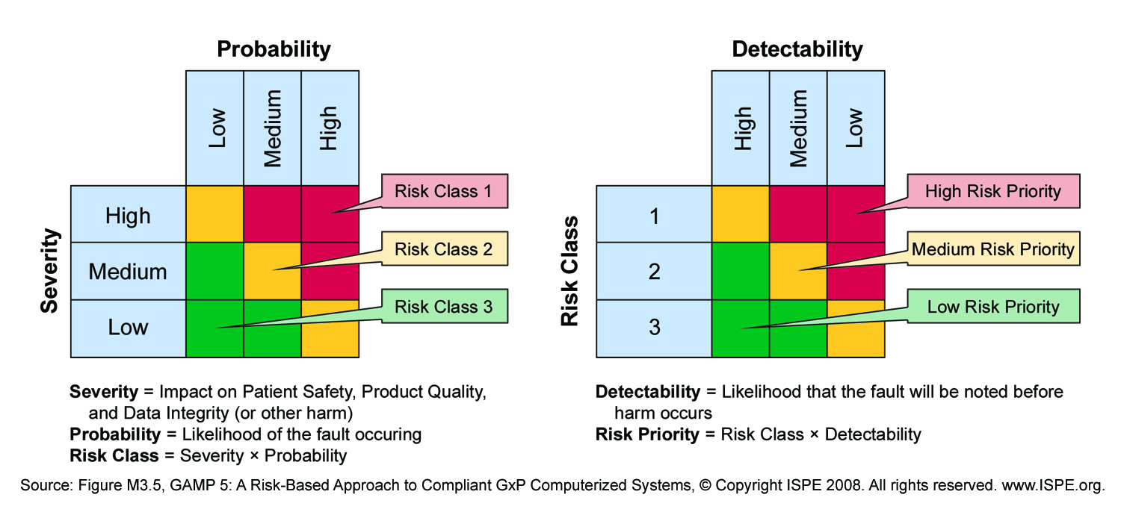

Figure 1: A Risk-Based Approach to Compliant GxP Computerized Systems (Source: Figure M3.5 GAMP 5)

The Risk Severity will be defined at the level of the URS. The risk probability and risk class will be described in the functional and technical specification documents.

# Requirements Information

## Requirement ID

A unique identifier is required for each requirement to allow traceability in later phases of the project. The requirements are identifiable in this document as they are reported in the format RIV_RNNN where RIV is the Application code, R is indicating that it is a requirement and NNN are unique 3 digit numbers.

## Requirement Risk Severity

Below are the definitions for the requirement risk severity with emphasis on identifying the risk criticality for the detailed risk assessment at the level of the User Requirement Specifications, Functional and Technical specifications. Requirement Risk Severity is documented in the Requirements contained within this URS.

| Risk Severity | Meaning |
| --- | --- |
| H | GxP critical requirement (GxP critical process requirement, i.e. impact on GxP regulations) |
| M | Business critical requirement (Business critical process requirement, i.e. impact on business activities |
| L | Nor GxP, nor Business critical requirements; nice to have (improves the system) |

# User Requirements

The following items are within the scope for the whole application

| **User Requirement Specification ID** | **User Requirement Specification Description** | **User Requirement Specification Risk Severity** | **Comment** |
| --- | --- | --- | --- |
|  | It should be possible to view images relating to the operation for each participant within the study | Medium | This is one of the primary purposes of the application |
|  | It should be possible to answer questions about each participants images. | Medium | Used for adjudication |
|  | It should be possible for a “Manager” to specify the questions to be asked about each image type | Medium | Used for adjudication |
|  | It should be possible to upload images associated with each participant to the system | Medium | This is one of the primary purposes of the application |
|  | It should be possible to specify the meta data that is to be associated with each of the uploaded images | Medium | This is one of the primary purposes of the application |
|  | User to confirm that all identifiable data has been removed from the image prior to uploading | High | For information security purposes |
|  | It should be possible to customise the application for a given study | Low | Branding can be important. |
|  | It should be possible to assign a subset of images to each user for review | Medium | To reduce burden |
|  | User home page to list the number of images outstanding for review | Medium | To reduce burden |

It is envisaged that the web-application has the following hierarchy:

It envisaged that the following workflows would be managed by the system

# Core Business Requirements

The following items are within the scope for the whole application

| **User Requirement Specification ID** | **User Requirement Specification Description** | **User Requirement Specification Risk Severity** | **Comment** |
| --- | --- | --- | --- |
|  | Users should have to login to access any reports or pseudo identifiable data | High | For data security purposes |
|  | Each user should be assigned to one of the following roles:   * Administrator (Can access all studies) * Manager (Can only access a specific study) * Supervisor (Can only access a specific study) * Uploader Supervisor (Can only access a specific study) * Reviewer (Can only access a specific study) | High | For data security purposes |
|  | The Reviewer role can   * Access a specific study * Access all images assigned to the user for review * Complete an assessment of the image, based on that defined by the manager | Medium | This is one of the primary purposes of the application |
|  | The Uploader role can:   * Access a specific study * Upload a participants images * Associate those images with a randomisation number and study time point * View a list of study participants for a site that are outstanding | Medium | This is one of the primary purposes of the application |
|  | The supervisor can:   * Undertake all activities that can be undertaken by an Uploader and Reviewer * View all results * View outstanding reviews | Medium | This is one of the primary purposes of the application |
|  | The manager can:   * Undertake all activities that can be undertaken by a supervisor * Setup users * Manage users (except for administrators) * Setup sites * Manage sites * Specify review questions | Medium | This is one of the primary purposes of the application |
|  | The administrator can:   * Undertake all activities that can be undertaken by a manager * Configure Studies | Medium | This is one of the primary purposes of the application |
|  | All uploaded images to be collated by study, site and status | Medium | To reduce burden |
|  | All images to be displayed as thumbnails | Medium | To reduce burden |
|  | Images when selected to be displayed in as large a format as possible, with the ability to zoom in | Medium | To reduce burden |
|  | Any changes to data should require a reason for change | High | For data security purposes |
|  | User must be able to reset their own password without administrator action | High | For data security purposes |
|  | All users must be able to have their access disabled | High | For data security purposes |
|  | Password rule to be enforced:   * 12-20 Characters * At least one Upper case * At least one lower case * At least one number * At least one special character * No spaces | High | For data security purposes |
|  | Contain a page to explain data usage and cookies for the application | High | Regulatory requirements |
|  | All pages displaying any patient data or user data can only be visible if logged in | High | For data security purposes |
|  | If no activity in the last 5 minutes display a pop-up warning that the user will be logged out in 2 minutes time | High | For data security purposes |
|  | Auto log the user out if no activity for 7 minutes | High | For data security purposes |

# Common Technical Requirements for the system

The following sections define requirements that are Common and Technical and that apply to the whole system.

| **User Requirement Specification ID** | **User Requirement Specification Description** | **User Requirement Specification Risk Severity** | **Comment** |
| --- | --- | --- | --- |
|  | All identifiable data to be encrypted at rest | High | For data security purposes |
|  | The application should only be accessible over a secure (https) connection | High | For data security purposes |
|  | The application should be written in PHP v7.1 | Low | PHP 7.1 is supported by all our servers |
|  | The application should use the Laravel 5.8 as the application framework | Low | This is a common framework that should be used where possible. |
|  | Application usable via Chrome version 74.0.3729.157 at a minimum | Low | Common Web browser |
|  | Application usable via Firefox version 67.0 at a minimum | Low | Common Web browser |
|  | Application usable via Internet Explorer version 11.766 at a minimum | Low | Common Web browser |
|  | Application usable via Edge version 42.17134.1.0 at a minimum | Low | Common Web browser |
|  | Application usable via Safari version 1.2 (windows) at a minimum | Low | Common Web browser |
|  | Application should be usable on a tablet with a minimum size of 9.7” | Low | Some users will access the application from a tablet |

# Reporting Requirements

The following items are within the scope for the whole application

| **User Requirement Specification ID** | **User Requirement Specification Description** | **User Requirement Specification Risk Severity** | **Comment** |
| --- | --- | --- | --- |
|  | It should be possible for a user to see a list of all their actions within the application | Medium | For auditing purposes |
|  | It should be possible for an administrator to see a list of all users actions within the application | Medium | For auditing purposes |
|  | It should be possible to view the review status of all images | Medium | For adjudication purposes |
|  | It should be possible to download a the results for all assessments with the format:  RandomisationNumber, Timepoint, Review1, Review2, Review3, DateOfReview1, DateOfReview2, dateOfReview3 | Medium | For adjudication purposes |
|  | It should be possible to obtain a list of outstanding reviews by reviewer | Medium | For adjudication purposes |
|  | It should be possible to obtain a list of outstanding reviews by randomisation number | Medium | For adjudication purposes |
|  | List of missing but expected images | Medium | To minimise missing data |

# Application Page Layout

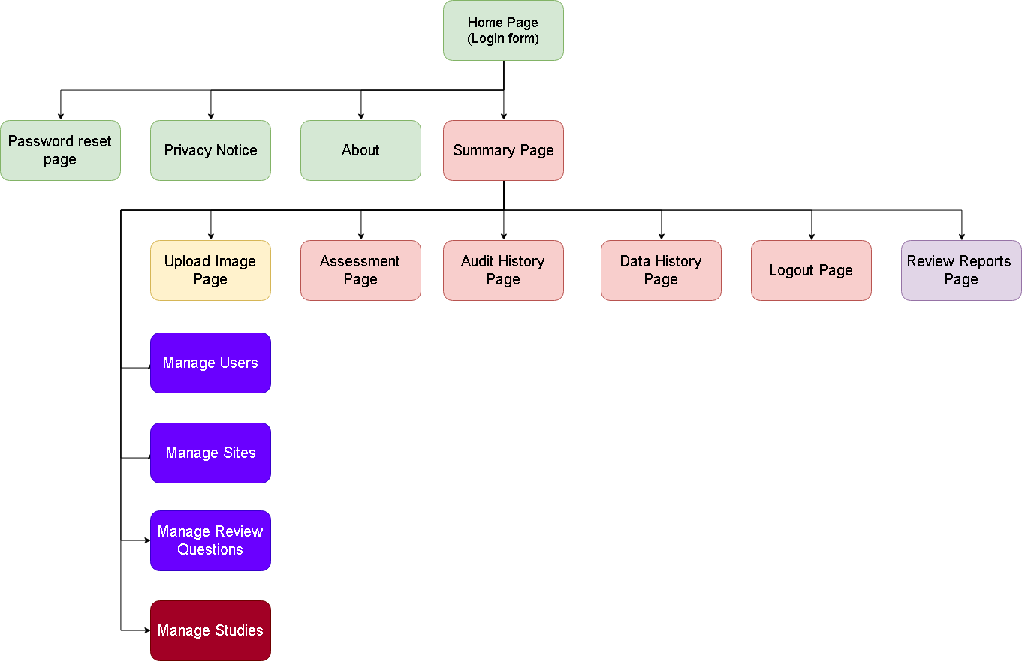

Figure : Application Page Layout